

**QGIS Lab Series**

**GST 102: Spatial Analysis**

**Lab 8: Raster Data Analysis - Density Surfaces**

**Objective – Learn Density Analysis Methods**

**Document Version:** **2014-07-30 (Final)**

**Author:**

Kurt Menke, GISP



**Contents**

1 Introduction 2

2 Objective: Learn the Basics of Terrain Analysis 2

3 How Best to Use Video Walk Through with this Lab 2

Task 1 Point Density 2

Task 2 Raster to Vector Conversion 6

Task 3 Vector to Raster Conversion 13

5 Conclusion 16

6 Discussion Questions 16

7 Challenge Assignment 17

1. Introduction

In this lab the students will learn about performing point density analysis. Density analysis can be used to show areas where there is a high occurrence of data. The lab will cover converting between vector and raster data.

This lab includes the following tasks:

Task 1 Point Density

Task 2 Raster to Vector Conversion

Task 3 Vector to Raster Conversion

1. Objective: Learn the Basics of Terrain Analysis

The objective of this lab is to learn about the density analysis methods and look at the conversion between the raster and vector data models.

1. How Best to Use Video Walk Through with this Lab

To aid in your completion of this lab, each lab task has an associated video that demonstrates how to complete the task. The intent of these videos is to help you move forward if you become stuck on a step in a task, or you wish to visually see every step required to complete the tasks.

We recommend that you do not watch the videos before you attempt the tasks. The reasoning for this is that while you are learning the software and searching for buttons, menus, etc…, you will better remember where these items are and, perhaps, discover other features along the way. With that being said, please use the videos in the way that will best facilitate your learning and successful completion of this lab.

1. Point Density

Point density analysis can be used to show where there is a concentration of data points. In this task, you will be using a core QGIS plugin called Heatmap, which generates point density surfaces.

**Radius (aka neighborhood)** – With the Heatmap tool you can define the search radius. The tool will use this distance when searching for neighboring points. A given pixel will receive higher values when more points are found within that search radius, and lower values when fewer points are found. Therefore, you can get very different results by changing the radius value.

1. The data for this lab is located on the lab machine at: *C:\GST102\Lab 8\Data.*
2. **Open QGIS Desktop 2.4.0.**
3. Use the **Add vector data** button to **add** the **Texas.shp** and **Place_names.shp** from the Lab 8/Data folder (**Figure 1**).

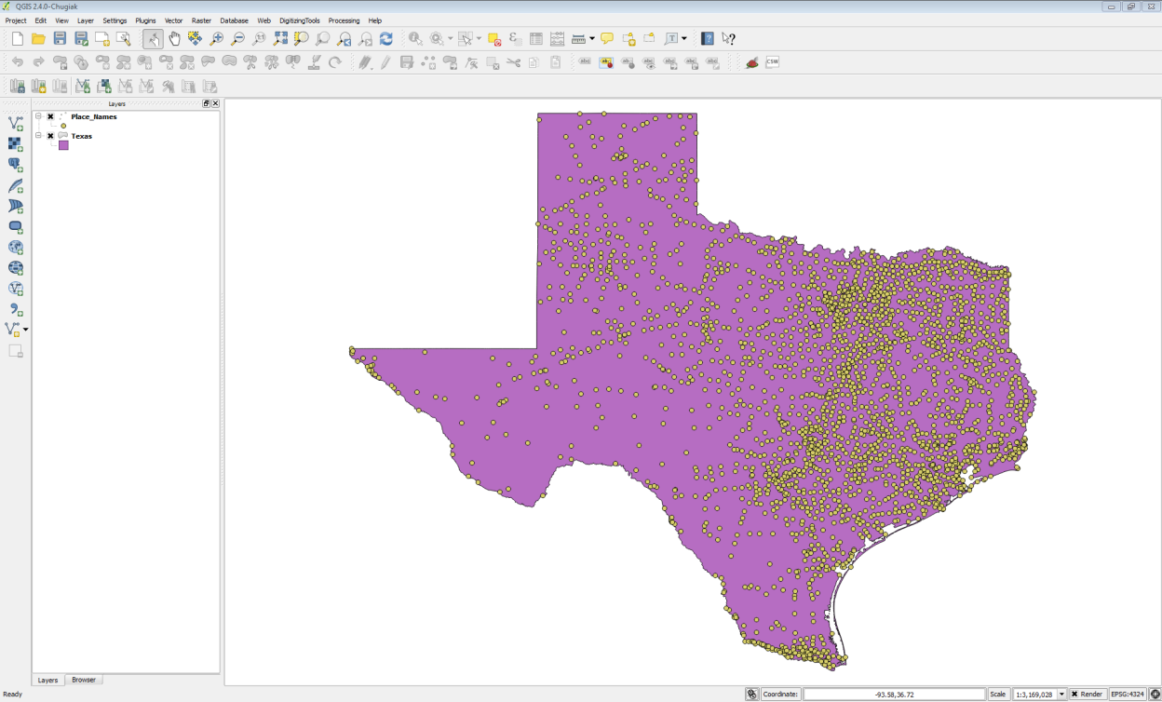

**Figure 1: Texas State Boundary and Place Names in QGIS Desktop**

1. **Save** your project as **Lab 8.qgs**
2. For this task, you will use the Heatmap plugin. From the menu bar choose **Plugins 🡪 Manage and Install Plugins**. Choose the **All Plugins** tab. **Type ‘*Heat*’** in to the **Search** bar and locate the **Heatmap** plugin. This is a Core QGIS plugin and it should be installed already. (NOTE: If it is not installed, install it.)

Once it is installed, **check** **the box to enable** it. **Close** the **Plugin manager**.

1. Now from the menu bar choose **Raster 🡪 Heatmap 🡪 Heatmap (Figure 2)**.
   1. Input point layer = **Place_Names**
   2. Output raster = **Data\MyData\TownDensity.tif**
   3. Output format = **GeoTIFF**
   4. Radius = **80000**
   5. **Click OK**

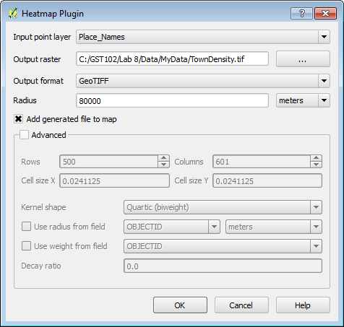

**Figure 2: Heatmap Parameters**

1. **Restyle** the **Texas** layer with a **Fill style** of **No brush** and a thick **yellow Border.**  Drag the Texas layer to the top of the Table of Contents (**Figure 3**).

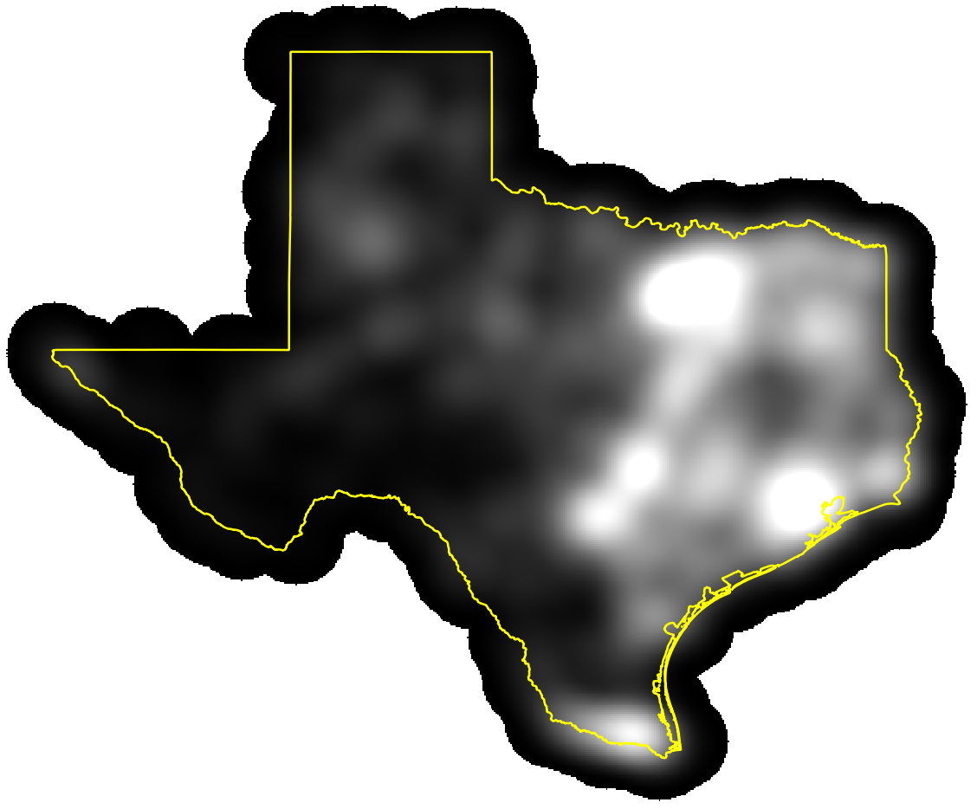

**Figure 3: Heatmap from Place Names**

1. Now you will run the tool again but you will weight the town points by their population. **Run** the **Heatmap** tool again. This time name the **Output** **TownPopDensity.tif**. **Check** the **Advanced** box and for the **Use weight from field** parameter use **Population**. This will create a heat map based on the population values of each town (**Figure 4**). **Click OK.**

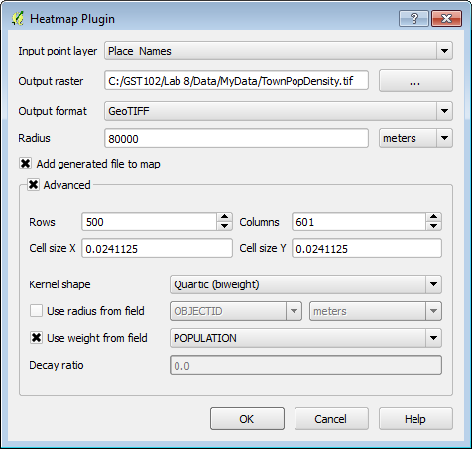

**Figure 4: Heatmap Parameters for a Population based Heat Map**

1. This method provides a much more accurate picture of where the population centers are, rather than just town density (**Figure 5**).

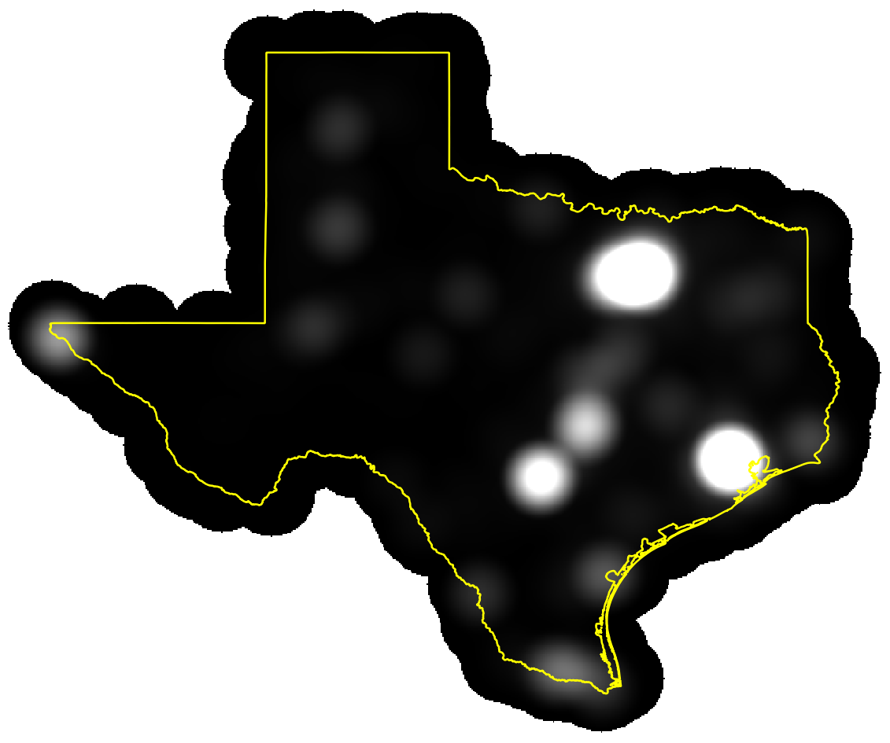

**Figure 5: Population Based Heatmap**

1. **Save** your project.
2. Raster to Vector Conversion

Sometimes it is necessary to convert data between the two main data models: vector and raster. Here you will convert the population based heat map to a vector dataset. Having the data in the vector data model allows for easier area calculations and different cartographic options (border and fill).

1. **Open QGIS Desktop 2.4.0** and open Lab 8/Data/**Lab8.qgs**
2. **Open** the **Layer Properties 🡪 Style** tab for the **TownPopDensity** raster.
   1. Render type **= Singleband pseudocolor**
   2. Color ramp **= YlOrRd**
   3. Mode **= Continuous**
   4. Accuracy **= Actual (slower)**
   5. **Click Load**
   6. **Click Classify**
   7. **Click OK** and **close** the **Layer Properties.**
   8. The map will nowresemble **Figure 6. (NOTE:** Here the state outline has been changed to black for better contrast.)

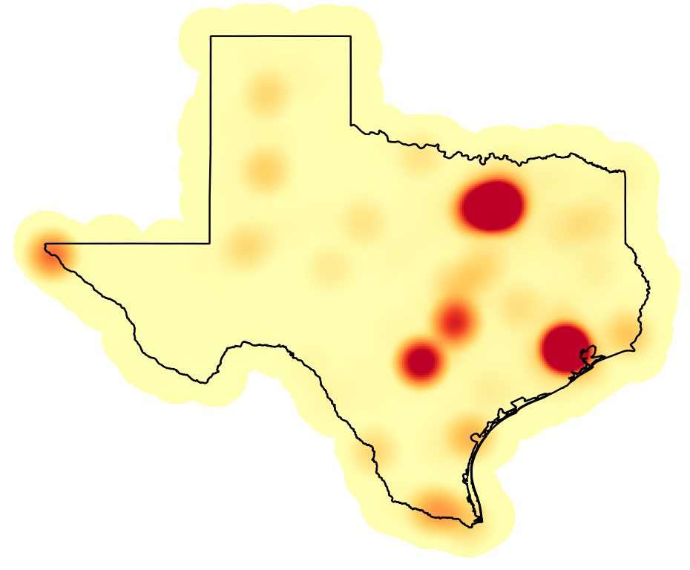

**Figure 6: Styled Population Based Heatmap**

This is a more pleasing rendering and is very useful for a visual interpretation of population centers. However, if you wanted to have an actual layer of these population centers the heat map needs to be further processed. You will now identify the highest population centers.

1. First, you need to decide on a threshold value that will constitute the population centers. There are a couple ways to do this. You can look at the values from the layer classification. You can also look at the **Layer Properties 🡪 Histogram**. Here you will use >900 as the threshold for population centers.
2. From the menu bar choose **Raster🡪 Raster Calculator*.***
   1. **Double click** on **“TownPopDensity@1”**
   2. **Click** on the **>** operator
   3. **Type** **900** in as the value
   4. Output layer = **PopulationCenter.tif**
   5. Output format **= GeoTIFF**
   6. **Click OK (Figure 7).**

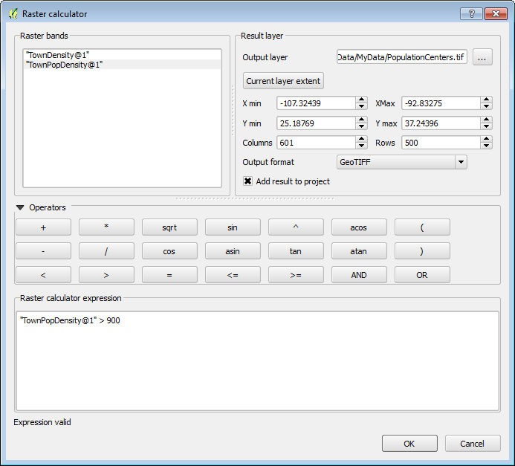

**Figure 7: Raster Calculator Parameters**

1. All the cells in the PopulationCenters raster input layer that had pixel values greater than 900 now have a value of 1, and the remaining pixels have a value of 0.
2. You will now convert the output to a vector layer. From the menu bar choose **Raster 🡪 Conversion 🡪 Polygonize (Raster to Vector)**.
   1. Input file (raster) = **PopulationCenters**
   2. Output file for polygons (shapefile) = **MyData\PopulationCenters.shp**
   3. **Check the box for Field name**
   4. **Click OK**. (**Figure 8**)
   5. **Click Close** when complete.

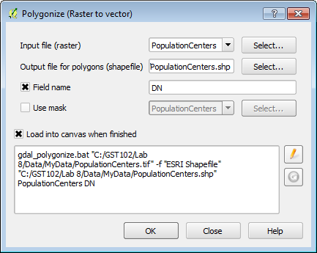

**Figure 8: Raster to Vector Conversion Parameters**

1. When the processing is complete, make sure the new polygon layer is above the raster layer in the Table of Contents so that it is visible.

Since the output represents all the pixels in the raster you need to eliminate the non-population center polygons from this layer. To do this you will put the layer into Edit mode, select those polygons with a value of 0 and delete them.

1. **Right click** on the layer and choose **Toggle editing** from the context menu.
2. Now **open** the **attribute table** for the layer. **Click** the **Select features using an expression** button .
3. **Expand Field and Values**. **Double click** on **DN** to place it in the **Expression** window. **Click** the **=** operator. Now **click** the **all unique** button and **double click** on the **0** value to place it in the expression. (**Figure 9**) **Click Select**. **Click Close.**

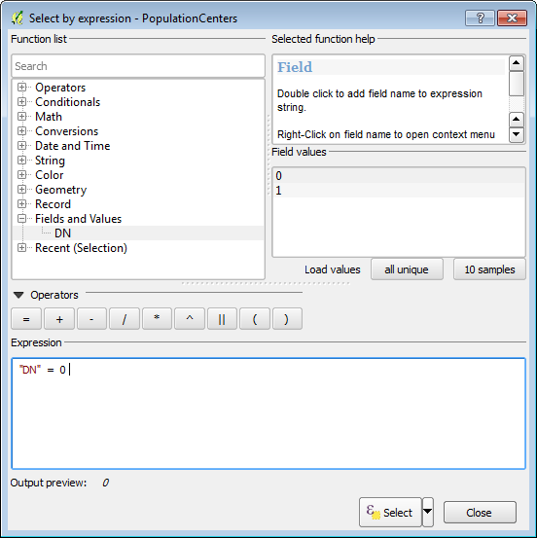

**Figure 9: Select by Expression**

1. Now that the records with a value of zero are selected, and the layer is in edit mode, **click** the **Delete selected features (DEL)**  button. Lastly **click** the **Toggle editing mode** button and **Save** the changes. The population centers are now a polygon layer you can use in a final map, or perhaps to feed into another analysis (**Figure 10**).

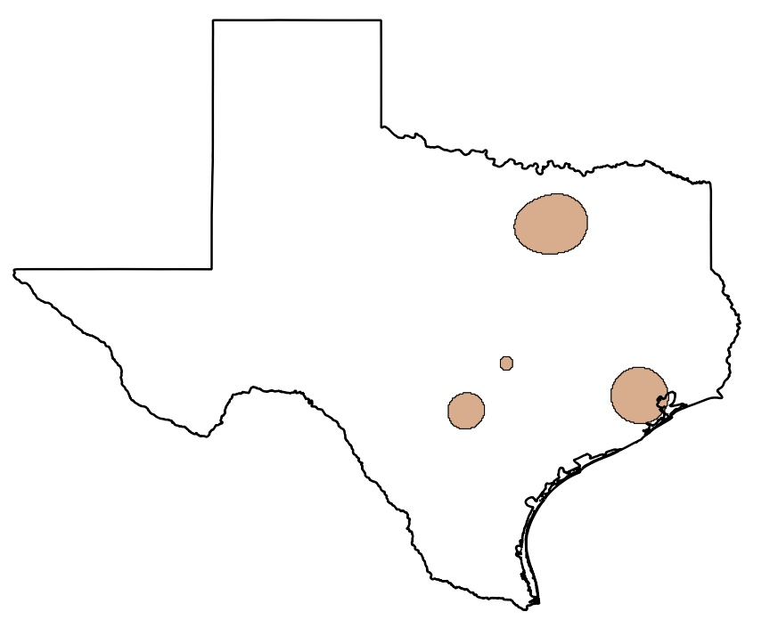

**Figure 10: Population Centers**

Now that the data are in polygon form, it is straightforward to calculate their acreage. QGIS calculates areas in the units of the coordinate reference system, therefore the layer needs to be in a Cartesian coordinate system with units of feet or meters. Currently it is in a Geographic coordinate system with values of decimal degrees. You will save the layer to a new coordinate reference system. Then you can calculate the square meters of the polygons and convert those to acres or square miles etc.

1. **Right click** on the layer and choose **Save as…**
   1. **Save the layer as PopulationCenters_albers.shp**
   2. **CRS 🡪 click** the **Browse** button toopen the **Coordinate Reference System Selector. Type ‘*Texas’*** into the **Filter** window**.**
   3. **Choose** the **NAD/83 Texas Centric Albers Equal Area EPSG:3083** CRS**. Click OK.**
   4. **Click Add saved file to map**
   5. **Click OK**
2. **Open** the **attribute table** for the **PopulationCenters_albers** polygon layer.
3. **Click** the **Toggle editing mode** button.
4. **Click** the **New column** button .
5. **Name** the column **Acreage** and make it a **Decimal number (real)** column**.** Give it a  **Width** of **7** and a **Precision** of **1 (Figure 11).**

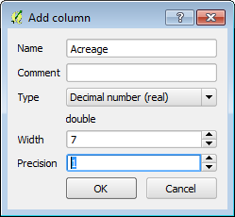

**Figure 11: Add column Parameters**

1. **Click** the **Open field calculator**  button.
   1. **Click** the **Update existing field** option
   2. Choose **Acreage** as that field
   3. **Expand** the **Geometry Function** list and **double click $area**
   4. **Click** the **\*** operator
   5. Enter the conversion factor from square meters to acres **0.000247105 (Figure 12)**
   6. **Click OK**.

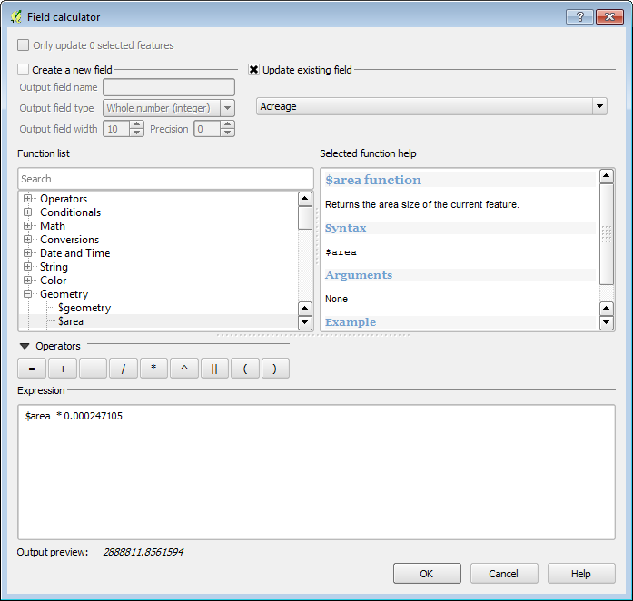

**Figure 12: Calculating Acreage**

1. **Toggle** **off** editing and **Save** your results (**Figure 13**).

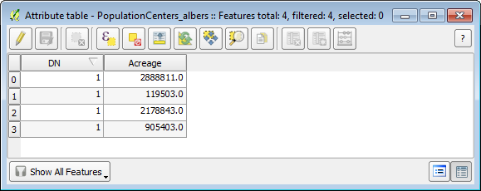

**Figure 13: Acreage Values Populated**

1. Now you have a layer of population centers and you have calculated their acreage!
2. **Save** your project.
3. Vector to Raster Conversion

It can also be very useful to have data represented in the raster data model. Rasters are very useful for analysis. In the last lab, you saw how rasters can be combined via the Raster Calculator. You can convert points, lines and polygons to a raster format. One must be cognizant of the effects of cell size. The data will be generalized when the conversion from precise vector locations to cells occurs. Here you will convert a vector layer to raster.

1. **Open QGIS Desktop 2.4.0** and open Lab 8/Data/**Lab8.qgs**
2. **Add** the **Nueces_Roads.shp** to **QGIS Desktop. Right click** and choose **Zoom to layer extent (Figure 14).**

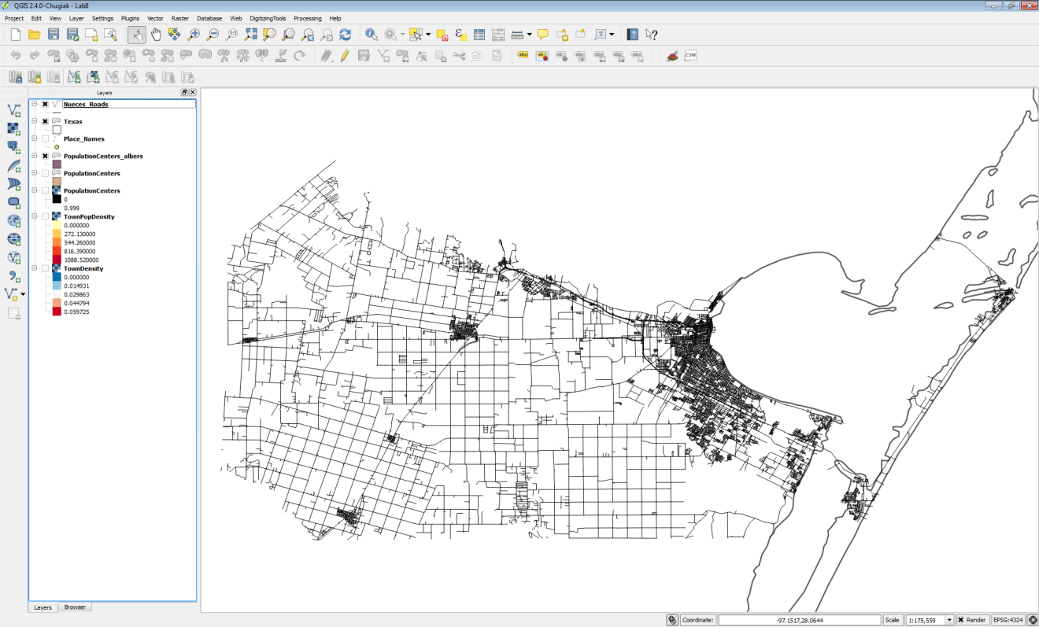

**Figure 14: Nueces Roads in QGIS Desktop**

1. From the menu bar choose **Raster 🡪 Conversion 🡪 Rasterize (Vector to raster)**.
   1. Input file (shapefile) = Nueces_Roads
   2. Attribute field = TLID (**NOTE**: this can be any numeric attribute. Often it will be a field that assigned some sort of weight to the output raster cells. Here we will simply use the TLID column.)
   3. Output file for rasterized vectors (raster) = **MyData\Roads_raster.tif (NOTE: If you get the message *‘The output file doesn’t exist. You must set up the output size or resolution to create it.’* Click OK.**
   4. **Take the remaining defaults.**
   5. **Click OK**. (**Figure 15**). **Click OK and Close.**

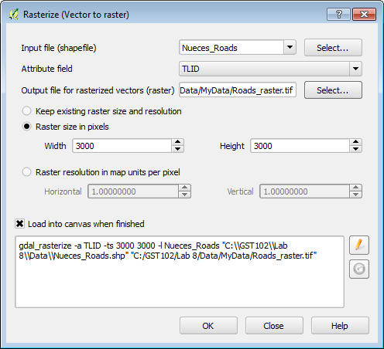

**Figure 15: Rasterize Parameters**

1. The resulting raster has values matching the TLID values for road pixels and values of 0 for the remaining pixels (**Figure 16**).

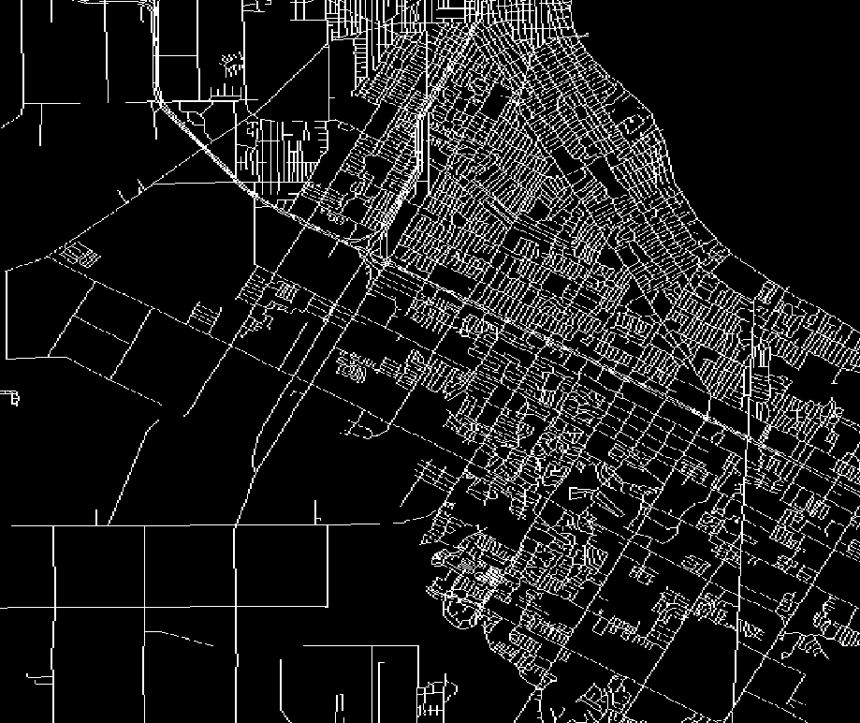

**Figure 16: Output Roads Raster**

5 Conclusion

In this lab, you learned how to use the Heatmap plugin to generate point density rasters based off of both point densities and attribute values (population). Density analyses are often used to analyze data related to crimes, or the amount of fast food stores in an area. The output provides a nice overview of how close the points are, and you can choose our own variables to weight the output. Finally, using the conversion tools we can convert between raster and vector. Having data in raster form allows you to perform raster algebra operations via the Raster Calculator. Having the data in vector form allows for geometries to be easily calculated (acreage), and for more sophisticated cartographic options (border and fill).

6 Discussion Questions

1. Discuss the different uses of point density.
2. Explain how weighting a feature via an attribute changes the outcome.
3. Is there anything we can do about the degradation of data in the conversion between vector and raster?

7 Challenge Assignment

In the Lab8/Data/Challenge folder there is a shapefile containing crime data for Surrey in the United Kingdom. There is a column for crime type (Crime_type). Use this field to generate two heatmaps: one for ‘Violent Crimes’ and one for ‘Drugs’. You will have to select records corresponding to each crime type, and save the selected features to a new shapefile for each. The heatmaps will be generated against the resulting shapefiles.